
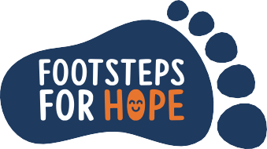























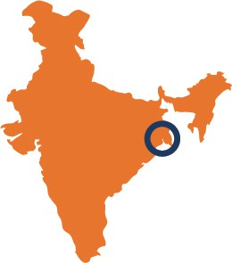

Congratulations!
You are half-way
.. If you need support or ideas for your fundraising, please get in touch.
(enter steps)
(enter steps)
(enter steps)
(enter steps)
(enter steps)
(enter steps)
(enter steps)
(enter steps)
(enter steps)
(enter steps)
Total Raised:
Total Steps:
Email:
(if applicable)
School:
(if applicable)
Age:

Name: (Example Sarah)
Day3
Day2
Day4
Day1
...It is okay to do more steps on some days
and less on others
Invite your friends to join the challenge or donate to HOPE
Day5
Day6
Day 7
Keep going!
you are doing brilliantly!
Day9
Day10
Day 8
If you have any questions, please contact:
juliette@thehopefoundation.org.uk
or for more information visit:
www.thehopefoundation.org.uk/footsteps/
Once your challenge is complete, to receive your certificate, please return this tracker to juliette@thehopefoundation.org.uk or post it to 82 Manor Road, Barton Le Clay,Bedford,MK45 4NR.
RegisteredCharityNo:SC038809
Share yourprogress onsocialmedia!

